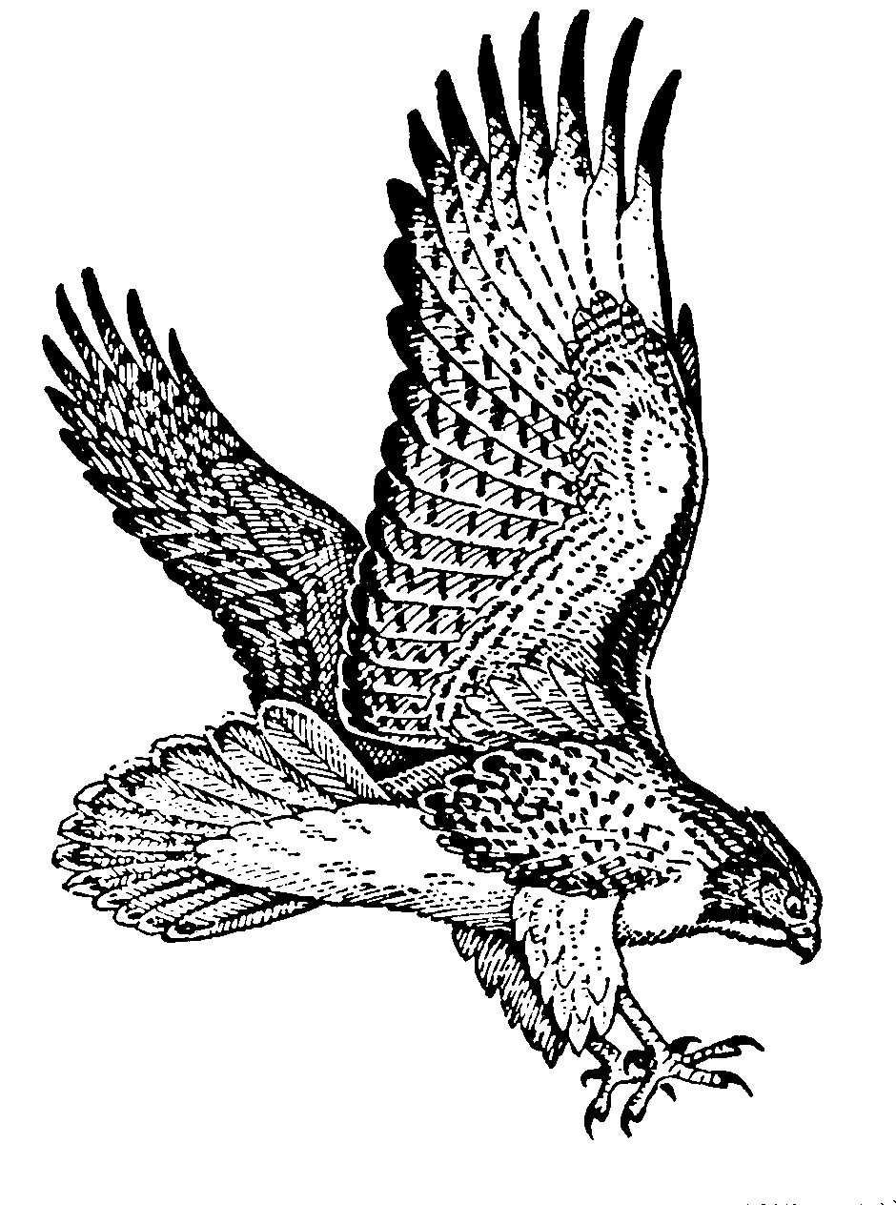High Springs Community School

Hawk Happenings – February/March 2023

Principal: Lynn McNeill  Assistant Principals: Emery Bishop & Jennifer Spencer

**Important Dates in February**

2/6: AWAY Basketball@ Ft. Clarke

2/8: HOME Basketball v. Westwood

FFA Meeting

2/11: FFA Horse Evaluation Finals

2/13: HOME Basketball v. Mebane

2/15: AWAY Basketball@ Howard Bishop

Green Club Meeting

2/16: Daddy Daughter Dance and Mother/Son Night

2/17: K-5 Kid’s Heart Challenge

Jr. Beta Winter Social

2/22: AWAY Basketball@ Oak View

2/23: 5th Grade Field Trip to Cade Museum

2/24: 6th/7th Gifted and 8th Grade Field Trip to NASA

**Middle School Sports**

**Soccer** tryouts for both boys and girls will be February 15th, 16th and 17th from 3:30 until 5:00 pm at the HSCS athletic field.

Students wishing to tryout must have a signed parent permission slip. Physicals and Insurance forms will need to be completed immediately upon notification of making the team. These documents are required once practice begins.

**PTSA News**

**Daddy & Daughter Dance and Mother & Son Night**

**February 16th!**

The last day to purchase tickets for both events is February 13th. There will be no tickets sold at either event. You can purchase tickets at the following link:

<https://hscs.memberhub.com/store?limit=21&live=true>

We are collecting Pop Tabs again. Students can turn them in to their homeroom teacher from

March 1st until April 7th.

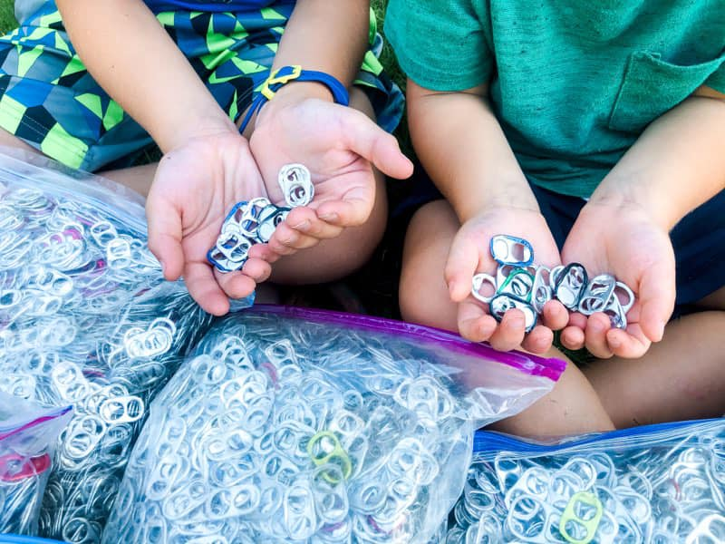

**The Classroom in EACH Grade Level that turns in THE MOST Pop Tabs will receive a Donut Party!**

**Kid’s Heart Challenge**

**February 17th!**

K-5 students will be celebrating all the great heart-healthy learning and activities they have been participating in this school year!

Donation envelopes are due the day of the Challenge, or you can visit: heart.org/KHC

**Kindergarten News**

The 100th day of school was great fun! Thank you for sending in items and participating in dressing up.

We will celebrate Dr. Seuss Week February 27th – March 3rd.

Monday – Wear Cool Socks

Tuesday – Wear Pockets

Wednesday – Wear Green

Thursday – Wear a hat

Friday – Wear red and blue or something fishy!





**FAST Testing**

K-8th grade students will complete Progress Monitoring #3 from April 17th to May 19th.

Results of Progress Monitoring #3 will be posted in Skyward Family Access.

High Springs Community School

Hawk Happenings –February/March 2023

Principal: Lynn McNeill  Assistant Principals: Emery Bishop & Jennifer Spencer

**Important Dates in March**

3/1: Jr. Beta Meeting

3/2-7: Alachua County Youth Fair and Livestock Show

3/6: 5th Grade Field Trip to Agricultural Fair

3/9: 5th Grade Fun Day at Citizens Field

3/10: 4th Grade Field Trip to St. Augustine

3/13-17: Spring Break

3/28: SAC Meeting @ 2:30

3/31: 3rd-5th Spring Fling

**Are you Interested in Mentoring Students?**

Students need positive role models in their lives. Mentors can help foster growth for students in many areas including academics and social awareness.

If you are interested in mentoring an HSCS student, please contact our Mentor Coordinator, Jennifer Brown, at [brownjf1@gm.sbac.edu](mailto:brownjf1@gm.sbac.edu) or 386-454-1958 ext. 2624.

**Girls on the Run**

Girls on the Run begins February 7th! They will meet every Tuesday and Thursday at 3:15 until April 18th.



**Student Art Exhibition**

Thomas Center Student Art Exhibition #1

Reception - February 9 - 6:30-8:30pm

Thomas Center Student Art Exhibition #2

Reception - March 2 - 6:30-8:30pm



**Grades 3rd- 5th Spring Fling**

**Friday, March 31st**

**6:00-8:00 pm in the cafeteria**



There will be drinks and wrapped snacks for sale!

**Beyond the Bell**

**Is your child in need of some extra tutoring or help with homework?**

Beyond the Bell provides free K-12 tutoring/homework help Monday through Thursday via Zoom with ACPS teachers.

Elementary: 3:00-4:00 pm & 6:00-7:00 pm

Secondary: ELA & Math – 6:00-7:00 pm

Science & Social Studies –

Tuesday and Thursday only 6:00 -7:00 pm

**Absent from School?**

You can now use Skyward Family Access to submit an absence note or request for your child.

The request can be submitted using the website: <https://www.sbac.edu/familyaccess> or the Skyward mobile app. The following link gives an overview of how to use the mobile app: https://youtu.be/vo5NP8MLyUE

Also, be sure to contact your child’s teacher for any make-up work, or for grades 6-8, check teacher pages in Canvas.

 