GHS

Young

Democrats

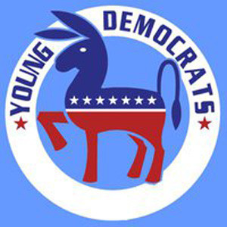

- Hearts and minds are not changed by force of battle. They are led to change by love and the gentle persuasion of conversation and thoughtful consideration.
-Claire Guthrie Gastañaga

- Human diversity makes tolerance more than a virtue; it makes it a requirement for survival.
-Rene Dubos

- I used to think anyone doing anything weird was weird. Now I know that it is the people that call others weird that are weird.
-Paul McCartney

- The highest result of education is tolerance.
-Helen Keller

The Young Democrats empowers high school students to get involved in the American political party system. Besides volunteering and talking about politics. We also give back to our community through community service projects and campaigns. High School Democrats train themselves and others in the ways of leadership, to become leaders both now and in the future.

Upcoming Events for the
2012-13 school year
September / October
PRIDE Month
Gay Pride Celebration held in downtown Gainesville
November / December
Election Year Events

January / February
African-American Awareness
March / April
Women's Rights Month

CONTACT INFO
palmergw@gm.sbac.edu
nataliehasty@hotmail.com

- The father is always a Republican toward his son, and his mother's always a Democrat.
- Robert Frost

- The responsibility of tolerance lies in those who have the wider vision.
-George Eliot

- Laws alone can not secure freedom of expression; in order that every man present his views without penalty there must be spirit of tolerance in the entire population.
-Albert Einstein

Our purpose will be to stimulate in the young people of Gainesville High School an active interest and to promote leadership in governmental affairs. We will pursue the ideas of liberty, justice, and freedom for all regardless of race, religion, or sex. We will also foster and perpetuate the ideals and principles of the Democratic Party. We will pursue these ideas through support of the Democratic Party and its ideas, citizens, and candidates.

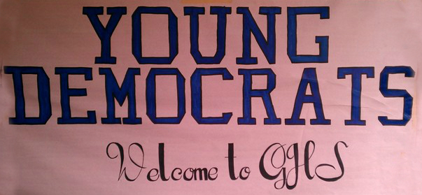

“If by a "Liberal" they mean someone who welcomes new ideas…, someone who cares about…the people-their health, their housing, their schools, their jobs, their civil rights and their civil liberties...
I’m proud to say I’m a Liberal
J.F. Kennedy

For information on open positions or to submit your resume, please visit our Web site at: www.lucernepublishing.com

