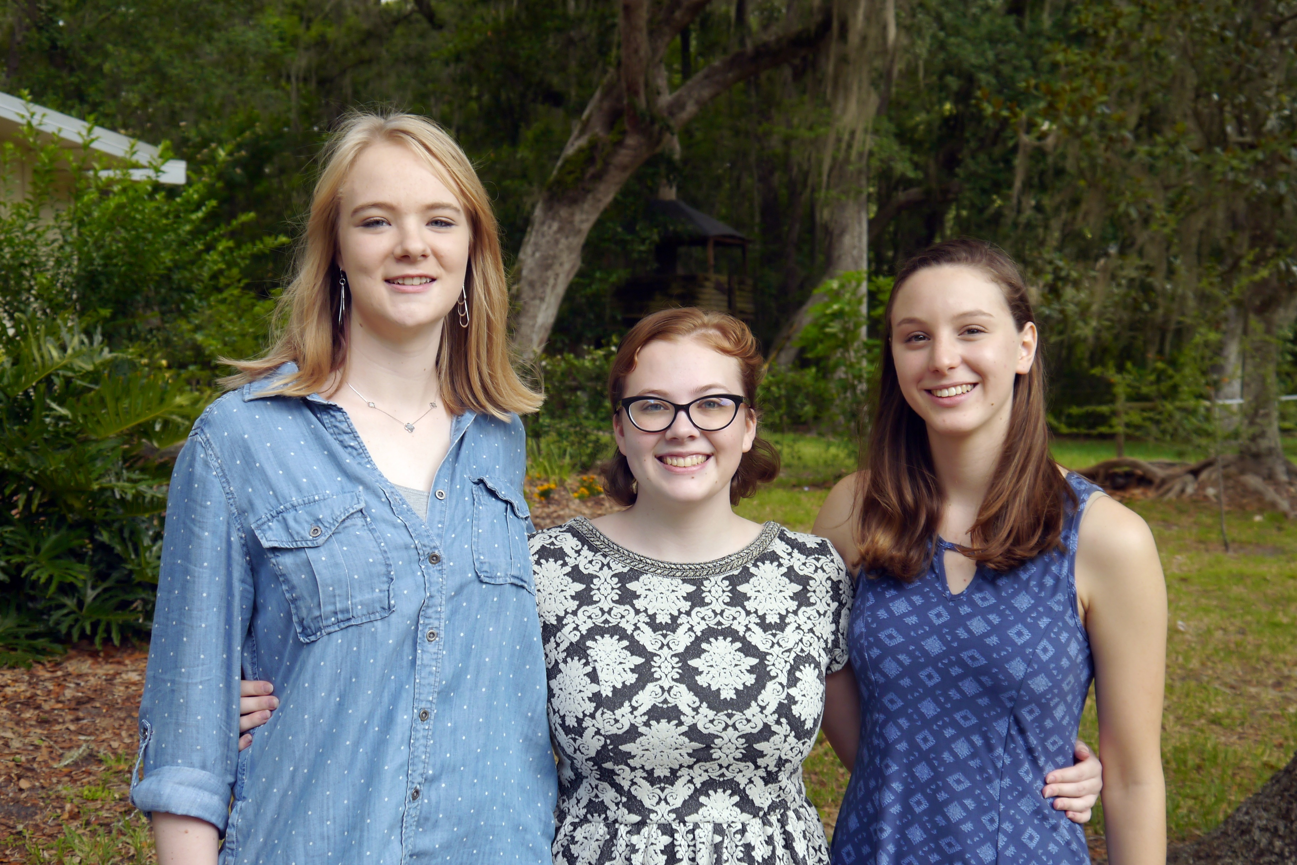
Foreign language is often something people overlook as an important part of higher level education. Learning a foreign language is good for increased communication skills, and can actually benefit some in bettering their understanding of their own language. Many native English-speakers in America believe that Spanish is the more advantageous language to study, especially for those living in South Florida, or in the Southwestern United States, but French is not a language that should be quickly disregarded.

Study French

And learn to speak the language of over 220 million people

Why French?
First off, to set the record straight, Spanish is not easier for English speakers to learn than French. In fact, English is a lot closer to French in terms of vocabulary; there are many cognates between the two languages, so even for people with no French background, there are definitely words that they can recognize. Also, once a person has learned French, it is much easier for them to learn other romance languages, including Spanish, Italian, Portuguese, Romanian, and Catalan!
Furthermore, French is the only language besides English that is spoken on five continents, making it a language worth studying for anyone who wishes to travel, above all those who are interested in careers in tourism, and international relations or business.

An up-and-coming opportunity to study French for middle school students.
Has the studying the French language peaked your interest? Well, if you are a middle school student at Westwood or Lincoln Middle School in Gainesville, FL, you are in luck! The French students at Eastside High School are sponsoring an afterschool French Outreach Program for students at these schools. It began in the fall of 2016 and will be continuing in the 2017-2018 school year.
Languages are not often taught in schools until 8th grade, which is rather unfortunate, since children have an easier time learning languages than adults. This program was designed to expose younger students to a language earlier than they normally would be. The students from Eastside High School who have at least 1 year of experience travel to Westwood and Lincoln every other week to teach the students French vocabulary and grammar, while teaching them about French culture as well. Language and culture have always been intertwined, so this outreach program is good for exposing students to different customs, cultures, and values, not just learning a foreign language.
Eastside is trying to grow our outreach program to reach the other middle schools in Gainesville. For more information regarding Eastside’s French Outreach Program, please contact Beatrice Torres at torresbg@gm.sbac.edu.
À plus!

Dagny B. von Mering

