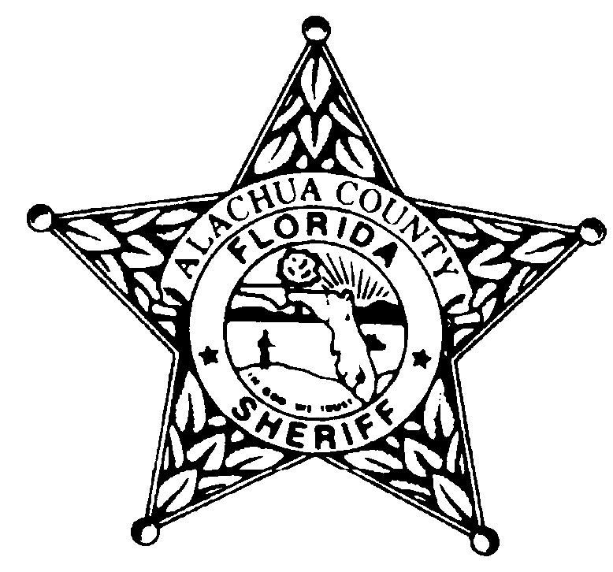

Alachua County Sheriff’s Office
Teen Court Program
Post Office Box 5489
Gainesville, Florida 32627-5489
Phone 352.367.4125 Fax 352.384-3328
Find us on Facebook: Alachua County Sheriff’s Office Teen Court

COMMUNITY SERVICE HOURS LOG SHEET

NAME: _______________________________________ Completion Deadline: ___________________ Number of Hours for Completion: ___________________

DATE | TIME IN | TIME OUT | TOTAL HOURS | BRIEF DESCRIPTION OF WORK COMPLETED | SUPERVISOR'S NAME  (Please make sure name is legible.) | AGENCY/ORGANIZATION | PHONE NUMBER

TOTAL HOURS __________

Volunteer’s Attitude: Excellent ____________ Very Good ____________ Average ____________ Poor ____________ (Please contact the Teen Court Office.)

Additional Comments: ___________________________________________________________________________________________________________________ ______________________________________________________________________________________________________________________________________

Please mail, fax, or hand deliver your community service log sheet to your case manager or any other Teen Court staff member when you have completed your hours.
For additional copies of the Teen Court community service sheet, defendant packet, or calendar, please visit: www.alachuasheriff.org (Click on “Teen Court” link.)

Olivia Hollier Teen Court Coordinator 352.367.4125 Fax: 352.384.3328 email: ohollier@alachuasheriff.org
Gregory E. Pelham, Sr. Teen Court Case Manager 352.367.4121 Fax: 352.384.3328 email: gpelham@alachuasheriff.org
DeAndre Fields Teen Court Case Manager 352.367.4129 Fax: 352.384.3328 email: dfields@alachuasheriff.org

